LOCATION RECCE (RECONNAISSENCE)

SCOUTING OUT
Q - What were your first thoughts when looking at the location(s)? (Online & In Person)

A – this location maybe a struggle to film in however its not impossible as there are safe spots where when closely looked I could position a camera and get a good angle shot.

PHOTOGRAPHIC EVIDENCE
Q - What pictures did you take of your location(s)? Please put them in this section and comment on why they are appropriate to film in.
A - 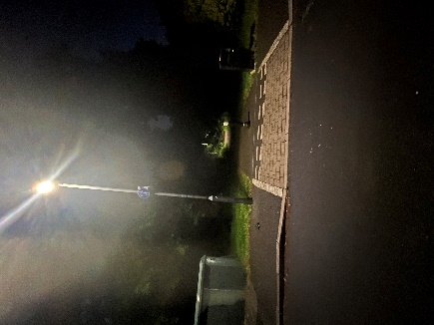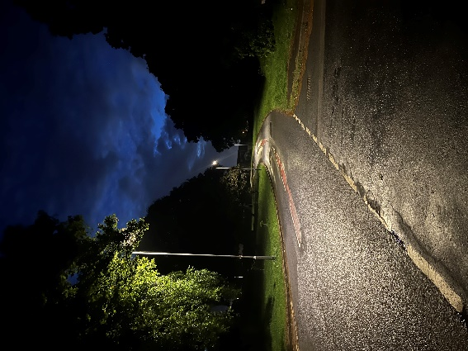

DIMENSIONS
Q - How big was the location? Does it fulfill all your needs for your project?
A – the location is big enough to fulfil its purpose however there could be a suggestion that its too big and the weather may affect this a lot.

LIGHTING
What was the quality of lighting like within the location? Was it natural (sunlight, fire) or artificial (bulbs/torches? Perhaps some pictures of what the lighting within the space with natural lighting and artificial lighting would be beneficial for your project?
The lighting in this area is decent as it’s a well lit road and doesn’t require too much extra lighting however for some takes I could have some low lighting to make sure the recordings are clear and can see the actors in the dark

SAFETY
Q - How safe is the location? Is it near any roads? Is it in an area which is out of bounds?
(REMEMBER FOR EVERY NEW LOCATION YOU ASSESS FOR YOUR PROJECT, YOU NEED TO HAVE A RISK ASSESSMENT AND LOCATION RECCE FORM THAT MATCHES THE LOCATION FOR THE PROJECT.)
A – this location does involve a road which is a potential hazard however to limit the possibilities of accidents and issues to safety I’m filming this scene in the dark and will be using a plan B road if this road is too dangerous to work with.

RESTRICTIONS & LEGAL MATTERS
Q - Do you know if the land is owned by anyone? Are you sure you have permission to film on there? If not, it might be best to find another location with easy access. If so, we will need to see a permission to film document included within your work.
(Including your Permission to Film document/email/slip on here will also let your client know that you have the correct access in where you need to film.)

A – this land is a public road therefore filming in this location should not be much of a problem however there could be some legal issues involving stopping a car on the road as well as obstructing and being slightly distracting to other possible road users to limit this I’m not going to use a major road like a dual carriageway as well as the time I’ll be filming will be less sociable.

