LOCATION RECCE (RECONNAISSENCE)

SCOUTING OUT
Q - What were your first thoughts when looking at the location(s)? (Online & In Person)

A – my thoughts on the underpass was it’s a safe location considering cars or people overcrowding the area will be limited due top the time and location. I thought there may be some problems with the lighting in the area however

PHOTOGRAPHIC EVIDENCE
Q - What pictures did you take of your location(s)? Please put them in this section and comment on why they are appropriate to film in.
A - 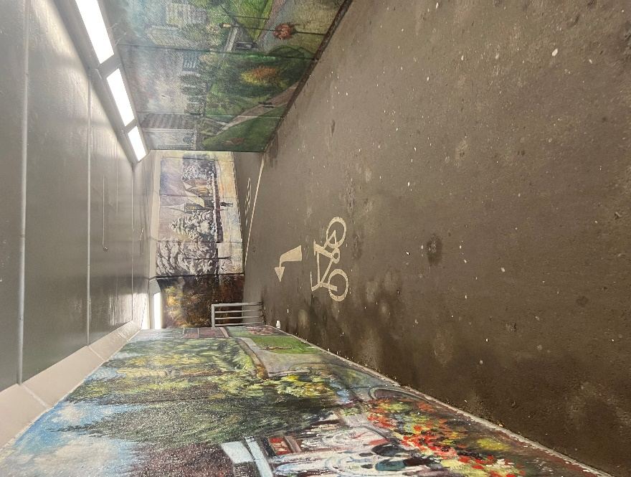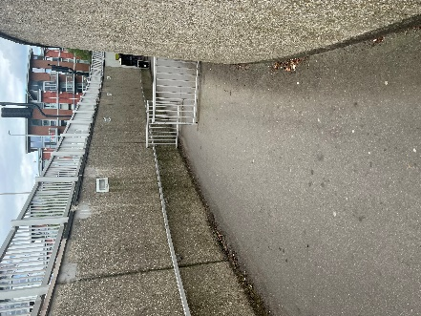

DIMENSIONS
Q - How big was the location? Does it fulfill all your needs for your project?
A – the underpass is very wide and can easily fit all the equipment needed as well as the actors will have enough space to perform.

LIGHTING
What was the quality of lighting like within the location? Was it natural (sunlight, fire) or artificial (bulbs/torches? Perhaps some pictures of what the lighting within the space with natural lighting and artificial lighting would be beneficial for your project?
As I will be filming in the dark ill need to utilize having artificial lights to brighten up some scenes that require it. I’ll be using normal streetlamps as a source of light as well as the mini portable lights.

SAFETY
Q - How safe is the location? Is it near any roads? Is it in an area which is out of bounds?
(REMEMBER FOR EVERY NEW LOCATION YOU ASSESS FOR YOUR PROJECT, YOU NEED TO HAVE A RISK ASSESSMENT AND LOCATION RECCE FORM THAT MATCHES THE LOCATION FOR THE PROJECT.)
A – this is a public underpass therefore there should be no initial safety issues however there is the risks of natural damage, theft, criminal damage, etc. which will all be in the risk assessment and explain how it’s going to be limited.

RESTRICTIONS & LEGAL MATTERS
Q - Do you know if the land is owned by anyone? Are you sure you have permission to film on there? If not, it might be best to find another location with easy access. If so, we will need to see a permission to film document included within your work.
(Including your Permission to Film document/email/slip on here will also let your client know that you have the correct access in where you need to film.)

A – the land is owned and maintained by the council however it’s a public used underpass which should not be a legal problem when filming as long as no one is filmed against their permission.

