LOCATION RECCE (RECONNAISSENCE)

SCOUTING OUT
Q - What were your first thoughts when looking at the location(s)? (Online & In Person)

A – my first thoughts were “this is going to be a perfect suspense creator” as I knew I wanted a climax to end the story or somewhere close and this was perfect easy access and really safe and secure.

PHOTOGRAPHIC EVIDENCE
Q - What pictures did you take of your location(s)? Please put them in this section and comment on why they are appropriate to film in.
A - 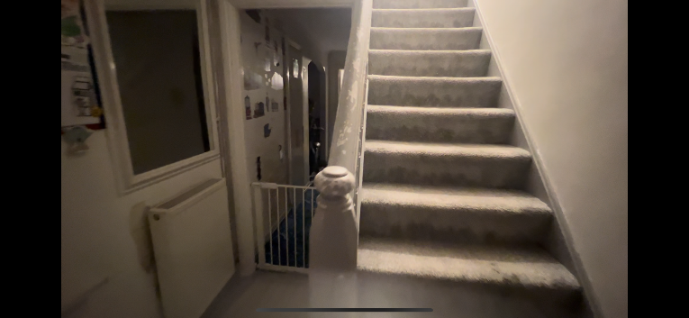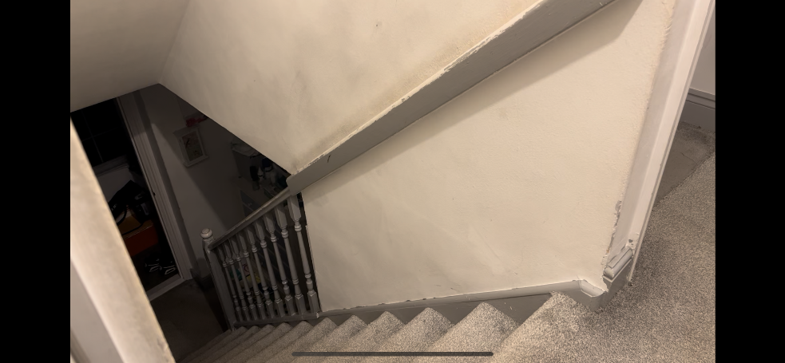

DIMENSIONS
Q - How big was the location? Does it fulfill all your needs for your project?
A – the location is not too big however it is big enough to film in as I’ve filmed in this location previously. The location can fit two crew members and all equipment with ease

LIGHTING
What was the quality of lighting like within the location? Was it natural (sunlight, fire) or artificial (bulbs/torches? Perhaps some pictures of what the lighting within the space with natural lighting and artificial lighting would be beneficial for your project?

The location will be primarily and solely artificial light such as lightbulbs and portable lighting I may use a police symbolic lighting to give an extra effect.

SAFETY
Q - How safe is the location? Is it near any roads? Is it in an area which is out of bounds?
(REMEMBER FOR EVERY NEW LOCATION YOU ASSESS FOR YOUR PROJECT, YOU NEED TO HAVE A RISK ASSESSMENT AND LOCATION RECCE FORM THAT MATCHES THE LOCATION FOR THE PROJECT.)
A – the location is extremely safe with no possibility of equipment getting robbed, car accidents, overcrowding etc. the location is completely legal and will not have any weathering problems for electricals.

RESTRICTIONS & LEGAL MATTERS
Q - Do you know if the land is owned by anyone? Are you sure you have permission to film on there? If not, it might be best to find another location with easy access. If so, we will need to see a permission to film document included within your work.
(Including your Permission to Film document/email/slip on here will also let your client know that you have the correct access in where you need to film.)

A – this is my house and doesn’t require any permission to film as well as there won’t be any new actors. There is no possible legal issues however there may be a police impersonation with the red and blue light however this is limited by using it for a shorter period of time.

