PERMISSION TO FILM CONTRIBUTOR FORM 2022
To whom it may concern,
My name is: sohaib rehan and I am a Creative Media student studying at Bracknell and Wokingham College. I am currently making a student project involving a: a nightmare in town We would like to use you as a contributor as well as your image within the entire duration of our production starting on (20th may 2022) to27th may 2022. A link to our project’s Production Schedule can be accessed here:
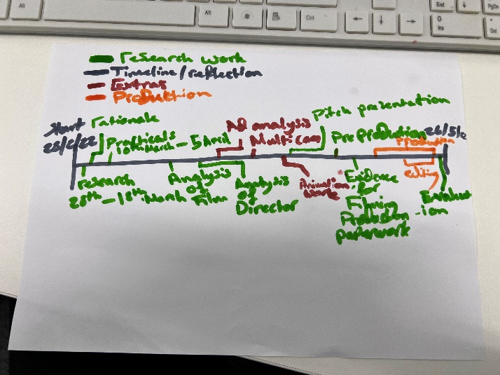
By signing this form, you understand that your voice and image will be recorded for the purpose of this film. The footage will be shot for the purpose of the ongoing project. However, the footage may also be used for other productions as ‘archive footage’ too (i.e. used in college marketing material, showcasing students work).
After the date of the production’s completion, the possession and rights of the footage will be solely for that of the college project. The footage will not be sold or passed onto anyone and will remain in the possession of the Creative Media department at Bracknell & Wokingham College for educational purposes.
If you have any issues or further questions you’d like to ask, please contact one of our vocational subject lecturers for more information.
Paul Boddy / Samuel Instone
(Lecturers – Media, Bracknell & Wokingham College)
paul.boddy@activatelearning.ac.uk | samuel.instone@activatelearning.ac.uk

CONTRIBUTOR’S PERMISSION
NAME: Umar malik, Sahil rehan, Zac chevasco, Frankie Emanuel, Lewis Allen
DATE: 28/05/22
SIGNATURE:U.M, SR,ZC,FE,LA

PRODUCER’S AUTHENTICATION
NAME(S): sohaib rehan
DATE:28/05/22
SIGNATURE(S):S.R

AUTHORISED BY MEDIA LECTURER
NAME: Paul Boddy
DATE:28/05/22
SIGNATURE: P.B

